**ASSIGNMENT-III**

**FERTILIZER RECOMMENDATION AND DISEASE PREDICTION USING AI**

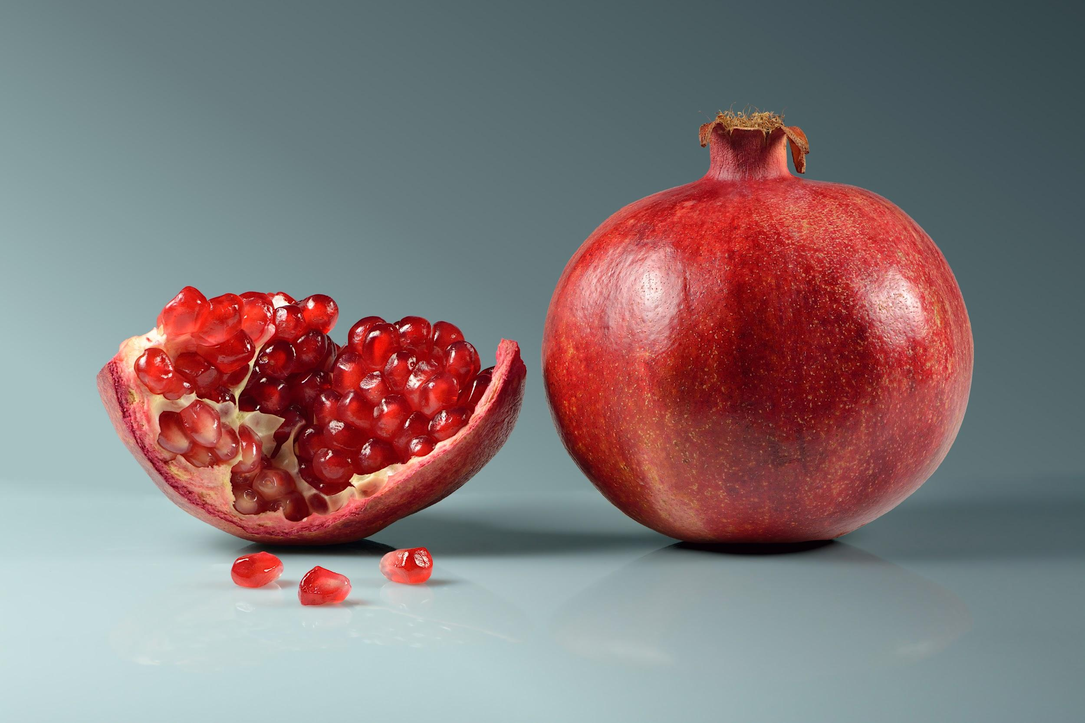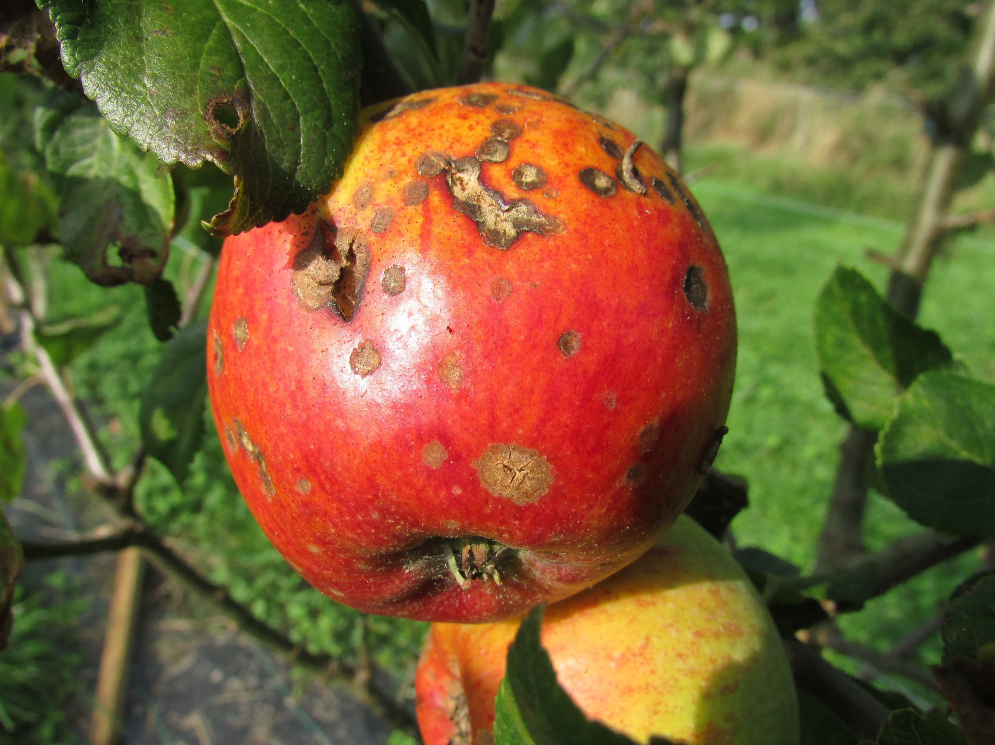

| **STUDENT NAME** | **1.MATHIARASI.J**  **(TEAM LEADER)-622219104015**  **2.R.KAVIPRIYA-622219104010**  **3.P.SANDHIYA -622219104024**  **4.MAMTHA.M-622219104013**  **5.SAABIRA.S-622219104023** |
| --- | --- |
| **DATE** | **31 October 2022** |
| **MAXIMUM MARKS** | **2 MARKS** |
| **MARKS ALLOTTED** |  |

**SOURCE CODE**

**import tensorflow as tf**

**from tensorflow import keras**

**import matplotlib.pyplot as plt**

**import numpy as np**

**from os import listdir**

**from os.path import join**

**import pandas**

**import cv2**

**import os**

**import random**

**In [6]: data_lead = 'D:/IBM Project/Flowers-Dataset/flowers'**

**folders_lead = os.listdir(data_lead)**

**print(folders_lead)**

**['daisy', 'dandelion', 'rose', 'sunflower', 'tulip'**

**In [10]: image_names = []**

**train_labels = []**

**train_images = []**

**size = 64,64**

**for folder in folders_lead:**

**for file in os.listdir(os.path.join(data_lead,folder)):**

**if file.endswith("jpg"):**

**image_names.append(os.path.join(data_lead,folder,file))**

**train_labels.append(folder)**

**img = cv2.imread(os.path.join(data_lead,folder,file))**

**im = cv2.resize(img,size)**

**train_images.append(im)**

**else:**

**Continue**

**In [11]:**

**train = np.array(train_images)**

**train.shape**

**Out[11]:**

**(4317, 64, 64, 3)**

**In [12]:**

**train = train.astype('float32') / 255.0**

**In [13]:**

**label_dummies = pandas.get_dummies(train_labels)**

**labels = label_dummies.values.argmax(1)**

**In [14]:**

**pandas.unique(train_labels)**

**Out[14]:**

**array(['daisy', 'dandelion', 'rose', 'sunflower', 'tulip'], dtype=object)**

**In [15]:**

**union_list = list(zip(train, labels))**

**random.shuffle(union_list)**

**train,labels = zip(*union_list)**

**# Convert the shuffled list to numpy array type**

**train = np.array(train) labels = np.array(labels)**

**In [17]:**

**model = keras.Sequential([**

**keras.layers.Flatten(input_shape=(64,64,3)),**

**keras.layers.Dense(256, activation=tf.nn.relu),**

**keras.layers.Dense(128, activation=tf.nn.relu),**

**keras.layers.Dense(6, activation=tf.nn.softmax) ])**

**In [18]:**

**model.summary() Model: "sequential_1"**

| **LAYER(TYPE)** | **OUTPUT SHAPE** | **PARAM#** |
| --- | --- | --- |
| **Flatten_1 (flatten)** | **(None,12288)** | **0** |
| **Dense_3 (Dense)** | **(None,256)** | **3145984** |
| **Dense_4(Dense)** | **(None,128)** | **32896** |
| **Dense_5(Dense)** | **(None,6)** | **774** |

**Total params: 3,179,654**

**Trainable params: 3,179,654**

**Non-trainable params: 0**

**In [19]:**

**model.compile(optimizer= tf.optimizers.Adam(), loss='sparse_categorical_crossentropy', metrics=['accuracy'])**

**In [21]:**

**model.fit(train,labels, epochs=15)**

**Epoch 1/15**

**135/135 [==============================] - 4s 33ms/step - loss: 0.9817 - accuracy: 0.6046**

**Epoch 2/15**

**135/135 [==============================] - 4s 33ms/step - loss: 0.9438 - accuracy: 0.6278**

**Epoch 3/15**

**135/135 [==============================] - 4s 32ms/step - loss: 0.9001 - accuracy: 0.6416**

**Epoch 4/15**

**135/135 [==============================] - 4s 32ms/step - loss: 0.8361 - accuracy: 0.6854**

**Epoch 5/15**

**135/135 [==============================] - 4s 33ms/step - loss: 0.8594 - accuracy: 0.6674**

**Epoch 6/15**

**135/135 [==============================] - 4s 32ms/step - loss: 0.8078 - accuracy: 0.6787**

**Epoch 7/15**

**135/135 [==============================] - 4s 32ms/step - loss: 0.7158 - accuracy: 0.7239**

**Epoch 8/15**

**135/135 [==============================] - 4s 32ms/step - loss: 0.7496 - accuracy: 0.7130**

**Epoch 9/15**

**135/135 [==============================] - 4s 33ms/step - loss: 0.7025 - accuracy: 0.7308**

**Epoch 10/15**

**135/135 [==============================] - 4s 33ms/step - loss: 0.6381 - accuracy: 0.7640**

**Epoch 11/15**

**135/135 [==============================] - 4s 33ms/step - loss: 0.5484 - accuracy: 0.8024**

**Epoch 12/15**

**135/135 [==============================] - 4s 33ms/step - loss: 0.5464 - accuracy: 0.8024**

**Epoch 13/15**

**135/135 [==============================] - 4s 33ms/step - loss: 0.5362 - accuracy: 0.8110**

**Epoch 14/15**

**135/135 [==============================] - 4s 33ms/step - loss: 0.5055 - accuracy: 0.8114**

**Epoch 15/15**

**135/135 [==============================] - 4s 32ms/step - loss: 0.4804 - accuracy: 0.8279**

**Out[21]:**

**In [22]:**

**model.save("D:/IBM Project/Flowers-Dataset/flowers.h5")**